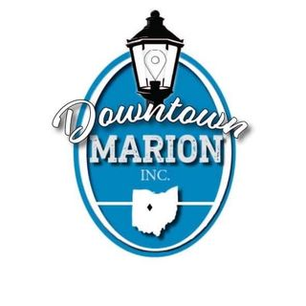

Partner with us!
Recognizing our past and redefining our future
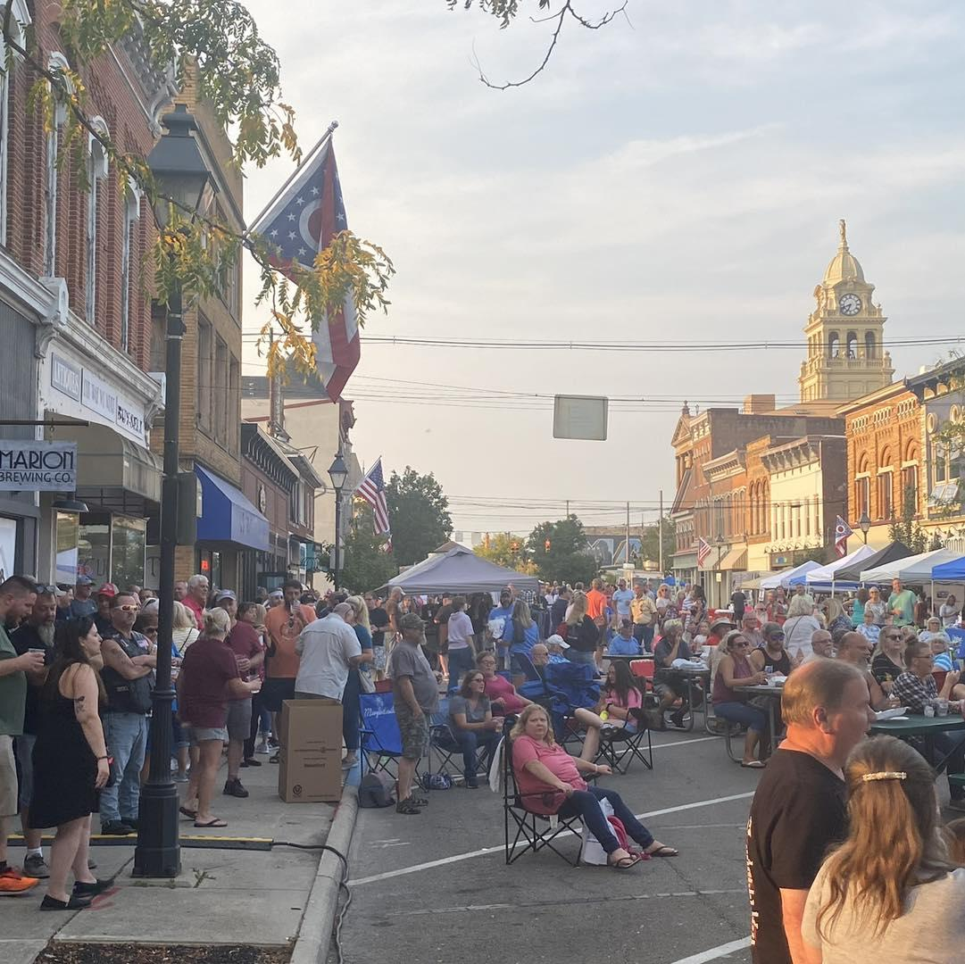
Why invest in Downtown Marion Inc?

All strong and vital communities possess strong and vital downtowns…without exception!
- 42 new retail stores, restaurants, public education entities, and professional services businesses since 2018
- Over 350 new full and part-time positions responsible for over $11 million in wages and salaries since 2018

Downtown Marion has become the cultural hub of our community
- 2000-3000 of all ages at each Third Thursday event
- Weekly farmers markets
- Monster March Trick or Treat serves over 2000 children each year
- Loft Tours
- Annual 5k race
- 3000 attend the new nighttime Christmas Parade
- 1500 at the annual Tree Lighting
- All participating churches report large crowds for the annual Holiday Church Tours
- 400 children visit Santa at his house in Founders park and each receive a present
- Two Saturdays of Secret Shopper for children during the Christmas season
- Highly successful Taste of Marion promotes downtown restaurants
- 108 downtown buildings are now named to the National Register of Historic Places as of 2022…aggressively protecting our history!

Keeping local dollars within our community
- Downtown merchants have enjoyed great staying power in the past five years
- Over 40 buildings have changed ownership in the past five years
- Downtown real estate has tripled in value over the past decade
- Downtown merchants report a dramatic increase in out-of-town customers

Downtown Marion, Inc. is a 501 (c) 3 organization in good standing. Your investment in DMI will be governed and managed by a 22-member volunteer board of directors comprised of civic leaders, city and county elected officials, downtown merchants, and professional community development strategists. Donations to Downtown Marion, Inc. are tax deductible as allowed by law.

Only your donation can help Downtown Marion Inc. continue to move downtown forward!
Contact: Downtown Marion Manager
Allen Wilson
manager@downtownmarion.com
Phone: 740-802-7329
Downtown Marion Inc.
267 W Center St. Suite 220
www.downtownmarion.com
@downtownmarionohio @downtownmarion
Community Partnership Opportunities

Friend of Downtown Marion $50
- Your name listed on the Downtown Marion Inc website sponsors page
- Downtown event / calendar notifications via e-newsletter
- Receive a free Sponsor of Downtown Marion Inc window cling

Business Sponsorship Opportunities

Business Sponsor of Downtown Marion $250
- Clickable name and business link listed on DMI website sponsors page
- Receive a free Sponsor of Downtown Marion Inc window cling
- Downtown event / calendar notifications via e-newsletter

Distinguished Sponsor of Downtown Marion $500
- Clickable name and business link listed on DMI website sponsors page
- Recognition on our social media platforms
- Receive a free Sponsor of Downtown Marion Inc window cling
- Downtown event / calendar notifications via e-newsletter
- Free vendor space set up during 3rd Thursday events (May-Sept)

Bronze Sponsor of Downtown Marion $1,000
- Clickable name and business link listed on ALL DMI website page as a sponsor
- Regular shares and mentions on social media
- Receive a free Sponsor of Downtown Marion Inc window cling
- Downtown event / calendar notifications via e-newsletter
- Free vendor space set up during 3rd Thursday events (May-Sept)
- Two free tickets to any DMI organized event all year long (business must contact downtown marion manager to request tickets per event)
- Highlight as “featured business of the month” on the Downtown Marion Facebook page (Business is responsible for sending pictures and write up to DMI via email 30 days prior to be highlighted on social media)

Silver Sponsor of Downtown Marion $2,000
- All the advantages of Bronze Sponsorship
- Verbal mention at all DMI organized events and shout out from the main stage on 3rd Thursdays
- Company logo on event web page, poster, marketing literature, on Silver Sponsor banners, and t-shirts (when applicable)
- Two free tickets to ALL DMI organized events for calendar year

Gold Sponsor of Downtown Marion $3,000
- All the advantages of Silver Sponsorship
- Your banner displayed at all DMI organized events (business provides banner to DMI)
- Four free tickets to ALL DMI organized events for calendar year

Platinum Sponsor of Downtown Marion $5,000+
- All the advantages of Gold Sponsorship
- Free table at the annual DMI Christmas Auction Fundraiser
- One free event rental of Harding Hotel Ballroom
- Six free tickets to ALL DMI organized events for calendar year
- Opportunity to address the audience at a DMI event of your choosing

Become a Legacy sponsor with a 5 year continuing pledge
Pledges are a major way to support the momentum which is creating a vibrant, revitalized Downtown Marion. If you like the potential you see, or remember what downtown could be, please consider one of the major donation levels, given over a five year span, listed on the form on the left side of this brochure.

- $5,000 / $1,000 for 5 years
- $10,000 / $2,000 for 5 years
- $25,00 / $5,000 for 5 years

